AIM: Perform Remote login using Telnet server.
TOOLS/SOFTWARES REQUIRED: Cisco Packet tracer
THEORY:
Telnet is an application layer protocol used to establish a remote command-line interface (CLI) session with a network device over a TCP/IP network.
It works on port number 23 and allows a user to control a router or switch from a remote system. Telnet follows a client-server model, where:
- The client (PC) initiates the connection
- The server (router) accepts the connection
In Cisco devices, remote access is enabled through VTY (Virtual Terminal) lines, typically numbered from 0 to 4, allowing multiple simultaneous sessions.
To secure access, a password is configured on VTY lines, and the login command is used to enforce authentication. The transport input telnet command enables Telnet as the allowed remote access protocol.
However, Telnet is not secure because it transmits data in plain text, making it vulnerable to interception. Hence, SSH is preferred in real-world networks, but Telnet is still used for learning and basic configurations

OUTPUT:
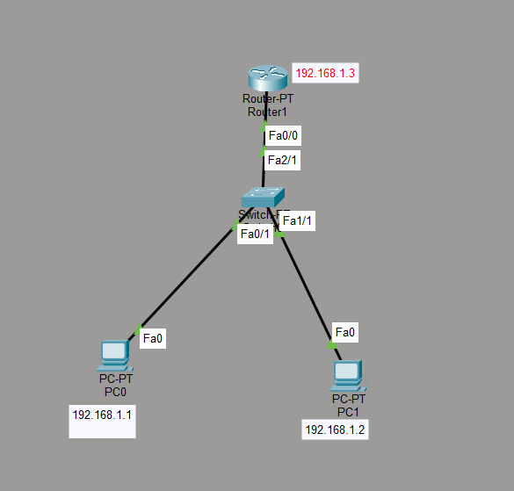
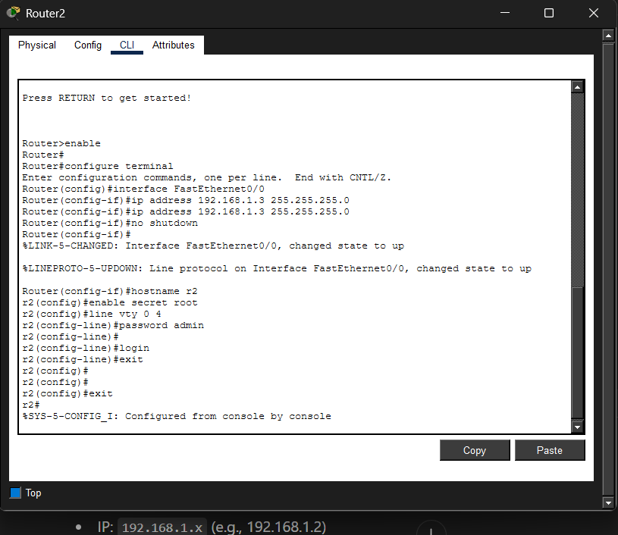
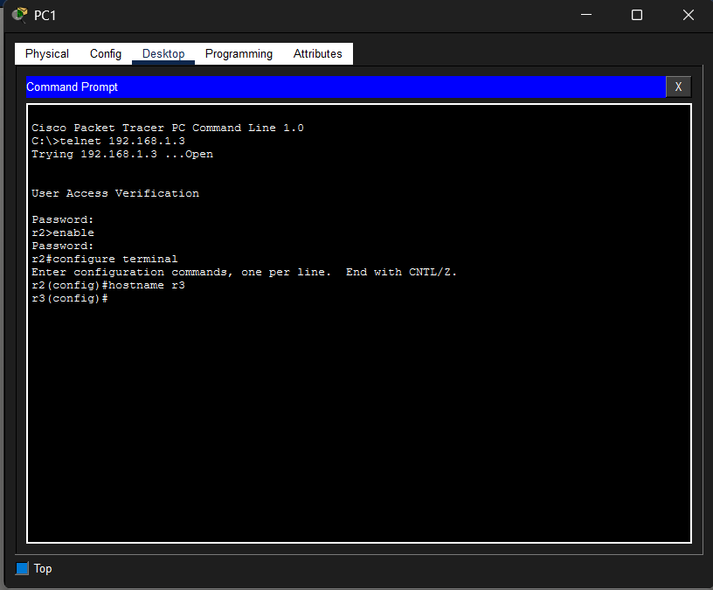

CONCLUSION:
The experiment successfully demonstrated how to configure Telnet on a router and access it remotely from a PC. It helped in understanding remote login, VTY line configuration, and basic network setup. The experiment also highlighted the limitations of Telnet in terms of security, as it transmits data in plain text, indicating the need for more secure alternatives like SSH.

